### CRM APPLICATION FOR JEWEL MANAGEMENT - (DEVELOPER)

**College Name: Kaamadhenu Arts and Science College**

**College Code: bru4p**

**TEAM ID : NM2025TMID21204**

**TEAM MEMBERS:**

**Team LeaderName: G. Saipriya**

**Email:** [**saipriya.cs23@kascsathy.ac.in**](mailto:saipriya.cs23@kascsathy.ac.in)

**Team Member: Ranjan .B**

**Email:** [**ranjan.cs23@kascsathy.ac.in**](mailto:ranjan.cs23@kascsathy.ac.in)

**Team Member: Rajeshwari .A**

**Email:** [**rajeshwari.cs23@kascsathy.ac.in**](mailto:rajeshwari.cs23@kascsathy.ac.in)

**Team Member: Priyadharshini .V**

**Email:** [**priyadharshiniv.cs23@kascsathy.ac.in**](mailto:priyadharshiniv.cs23@kascsathy.ac.in)

**1.INTRODUCTION**

**1.1 Project Overview**

The Jewel Inventory System is a comprehensive software Solution designed to streamline and manage the inventory and sales processes of a jewellery store or jewellery manufacturer.

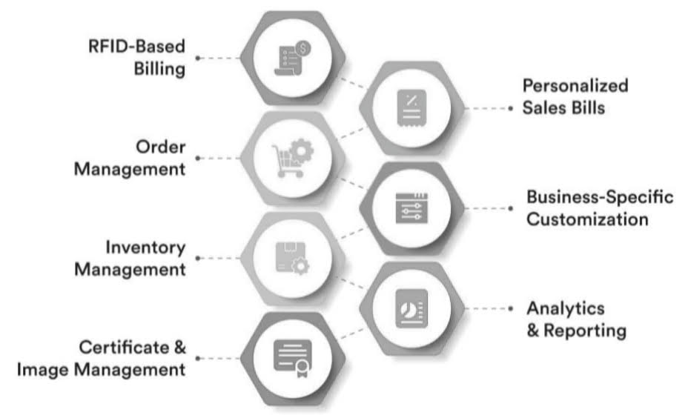

**1.2 Purpose**

The system aims to provide an efficient and user-friendly solution to track and control the inventory of various jewellery items, maintain accurate records, and facilitate seamless sales transactions.

**DEVELOPMENT PHASE**

**Creating Developer Account:**

By using this URL **-** [**https://developer.salesforce.com/signup**](https://developer.salesforce.com/signup)

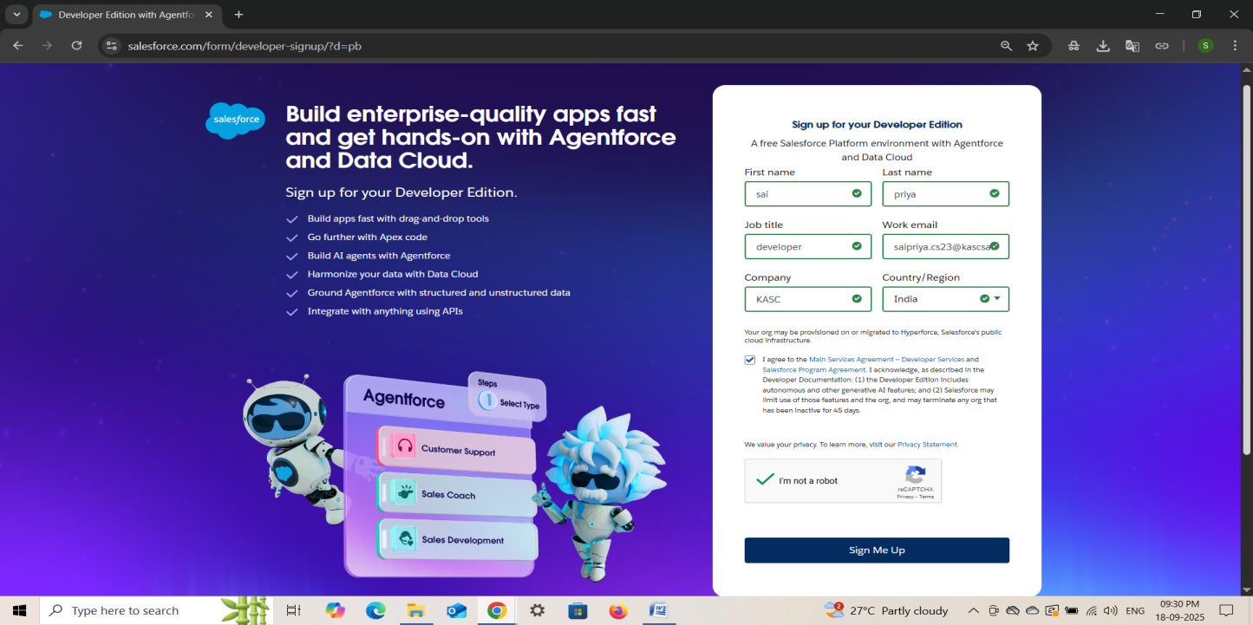

● Created objects: Jewel Customer, Item, Customer Order, Price, Billing

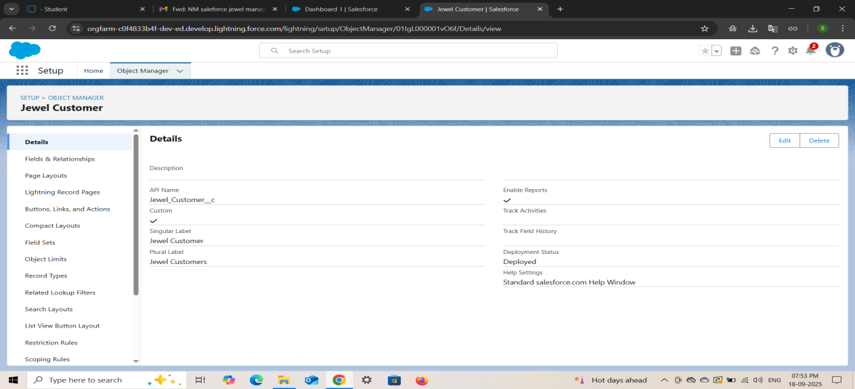

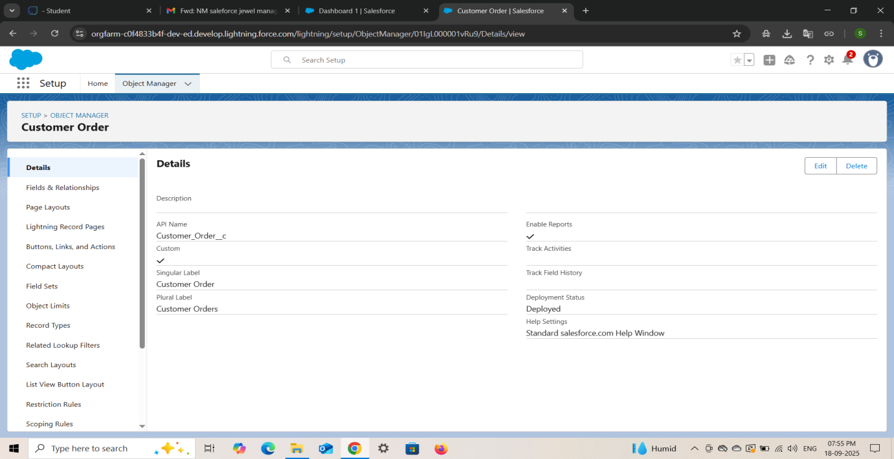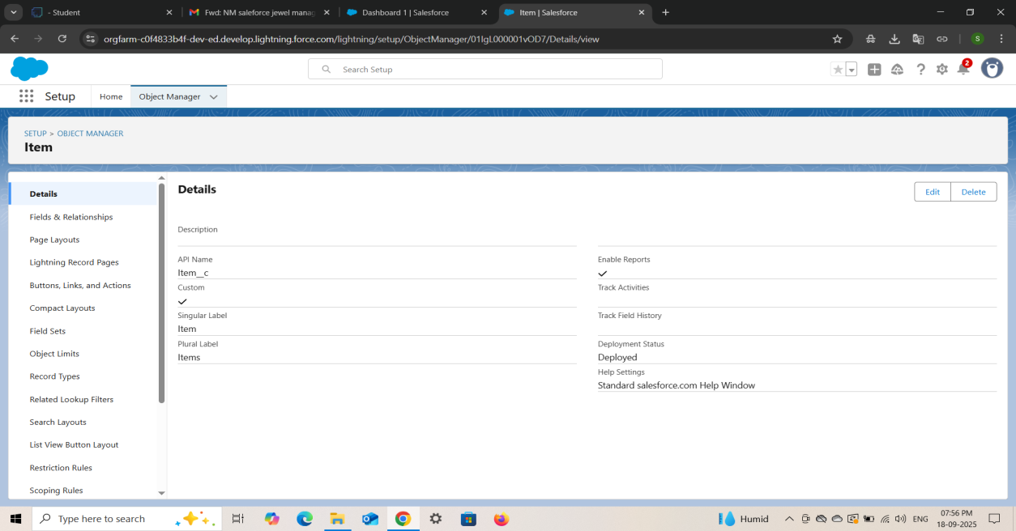

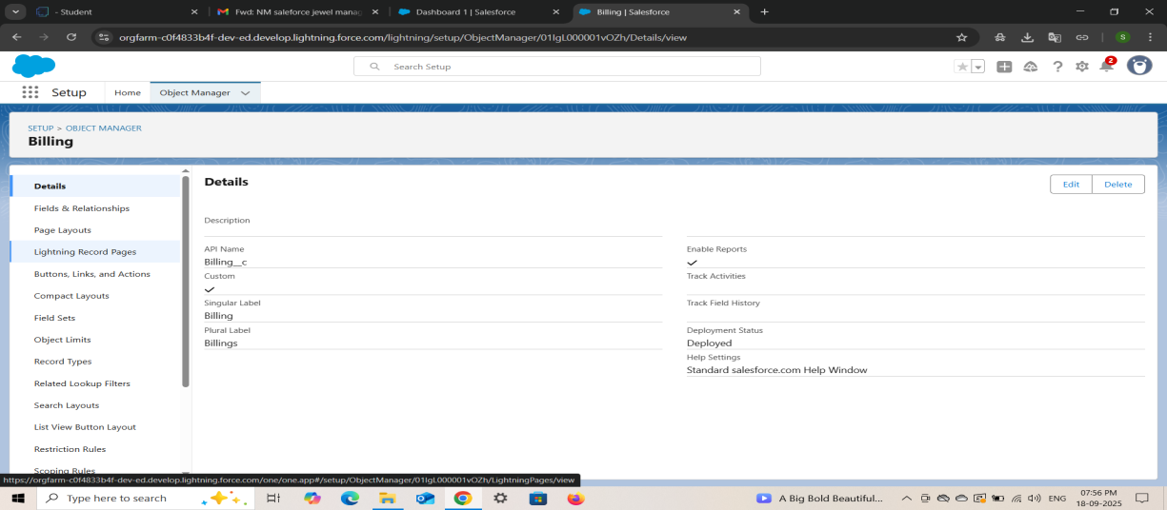

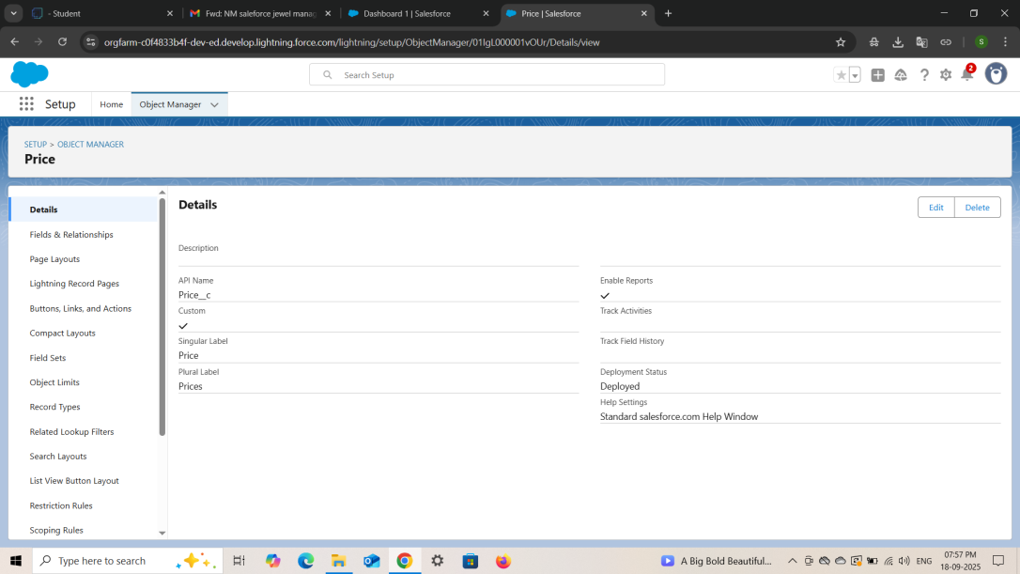

●Creating Custom tabs : Customer & Item

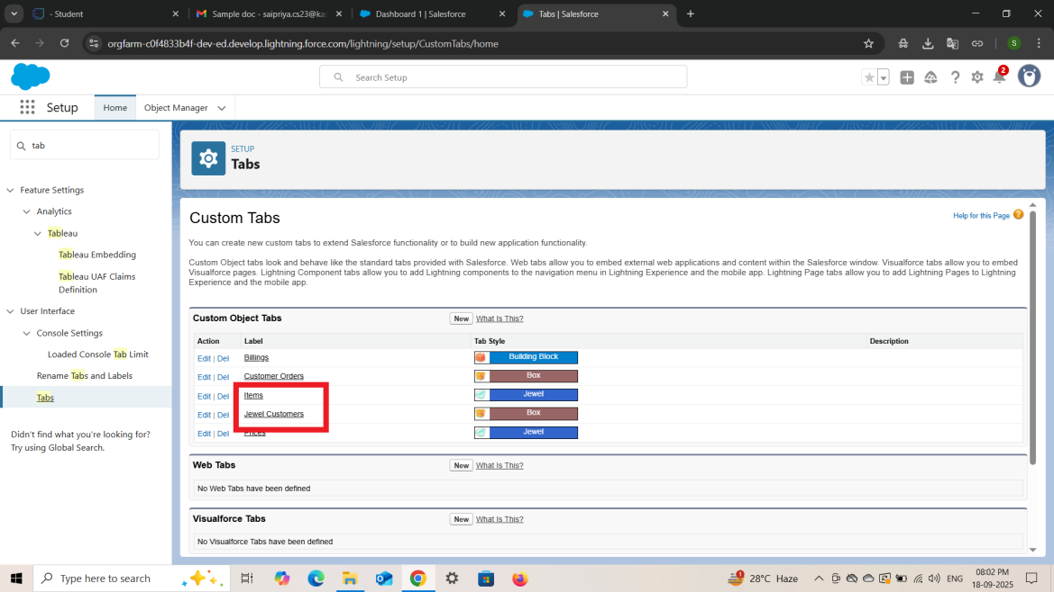

● Developed Lightning App with relevant tabs

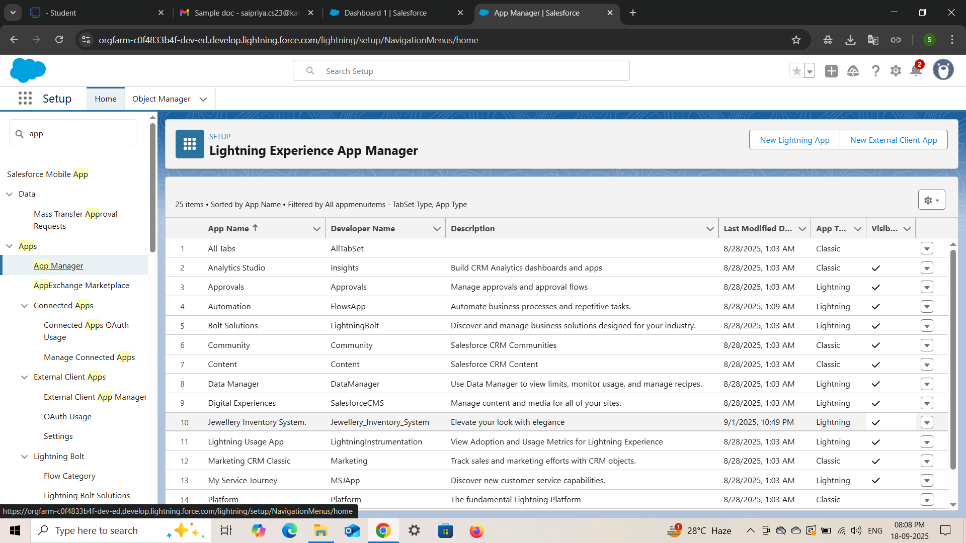

Fields :

● **Creating Lookup Relationship**

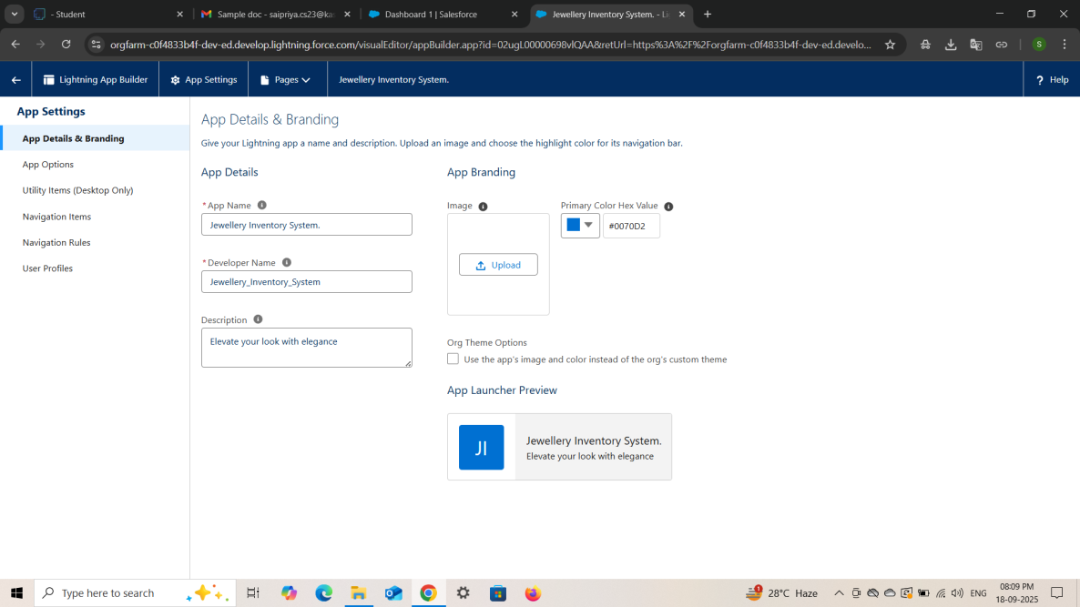

● **Creating a Master-Detail Relationship**

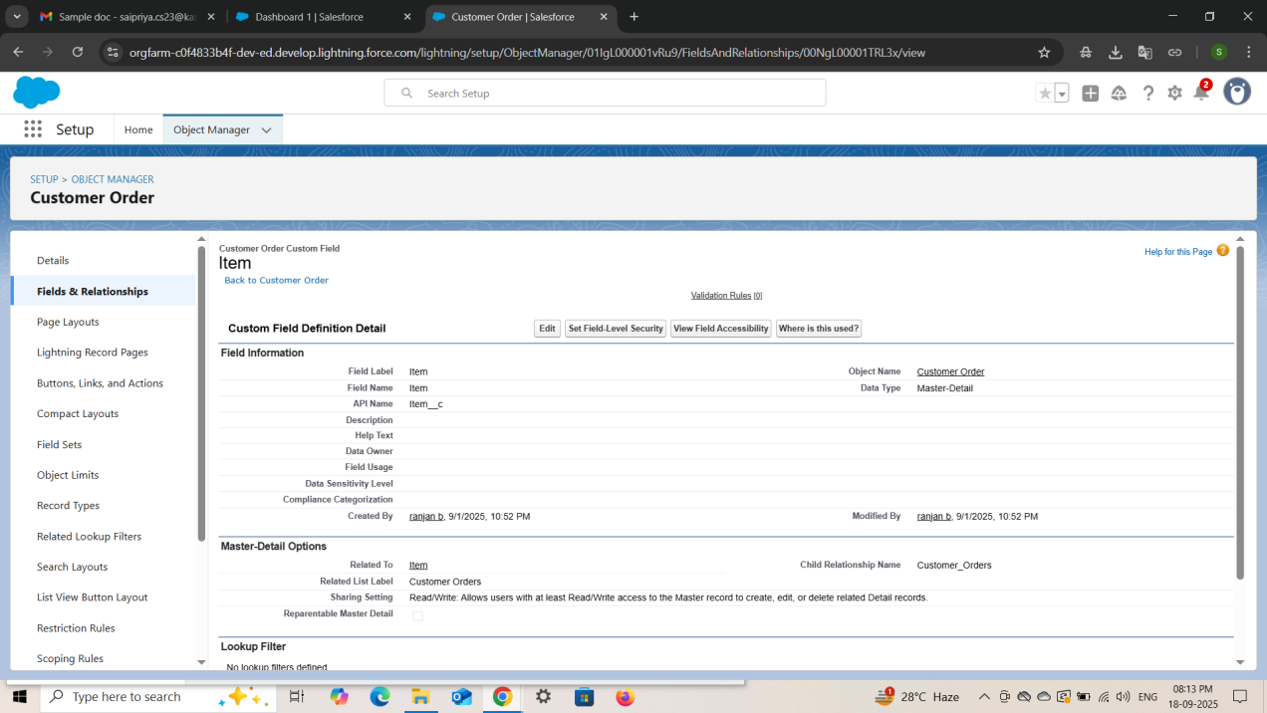

● **Creating Text Field in Jewel Customer Object**

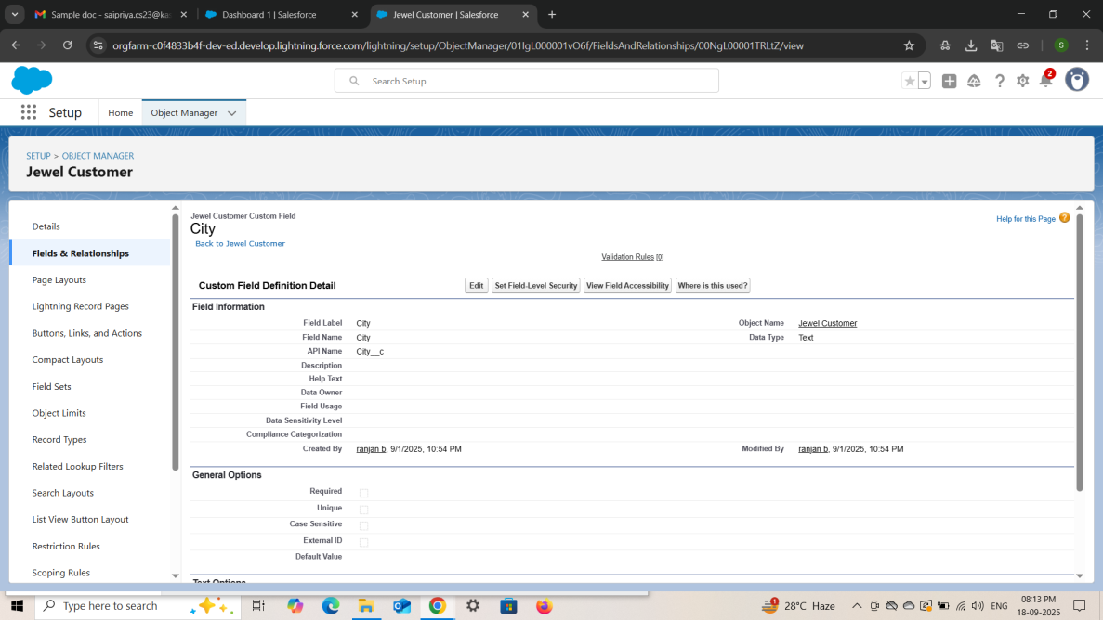

● **Creating the Phone field in object Jewel Customer**

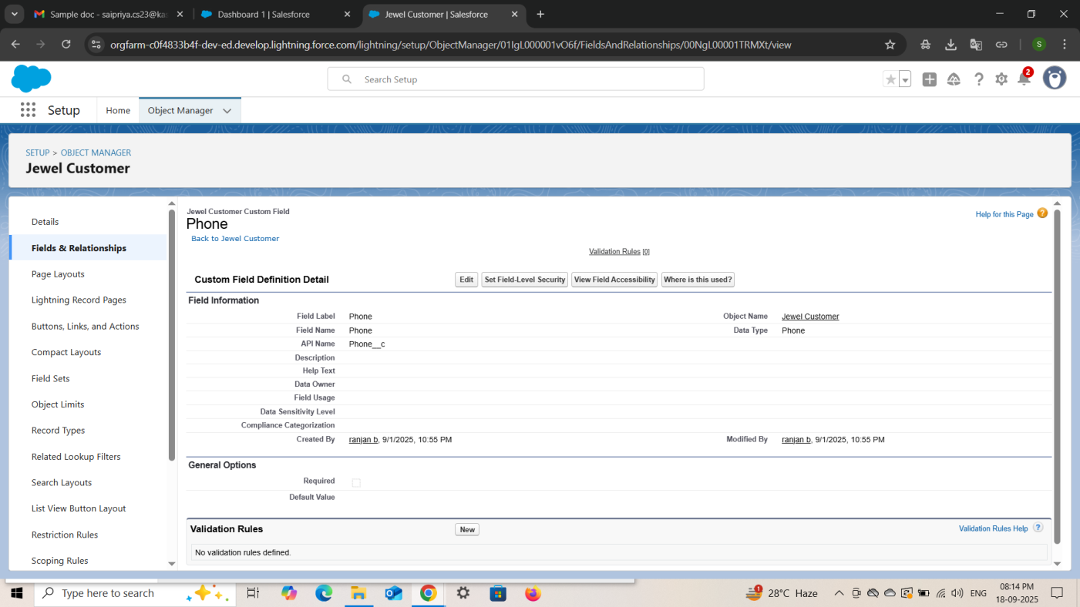

● **Creating the Email field in object Jewel Customer**

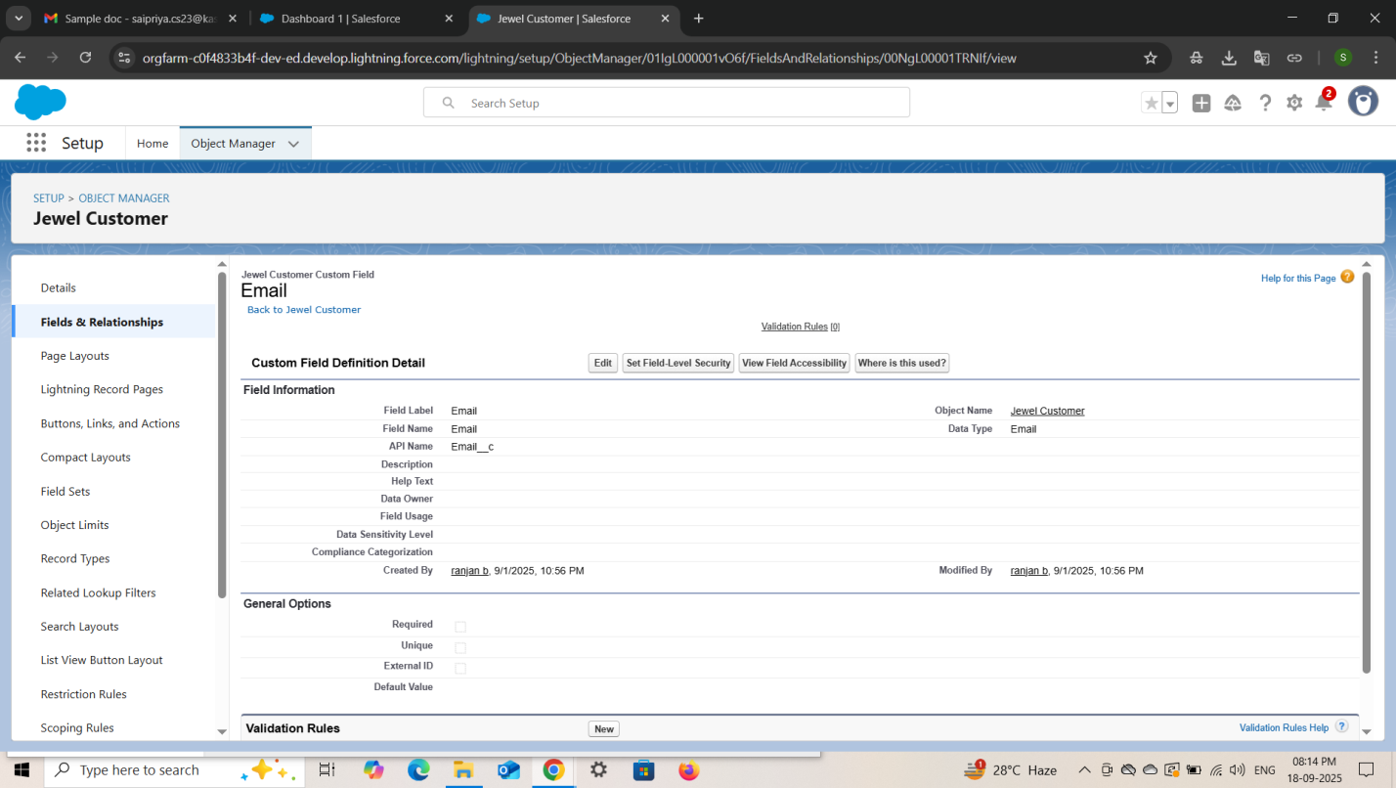

* **Creating the number field in Item object**

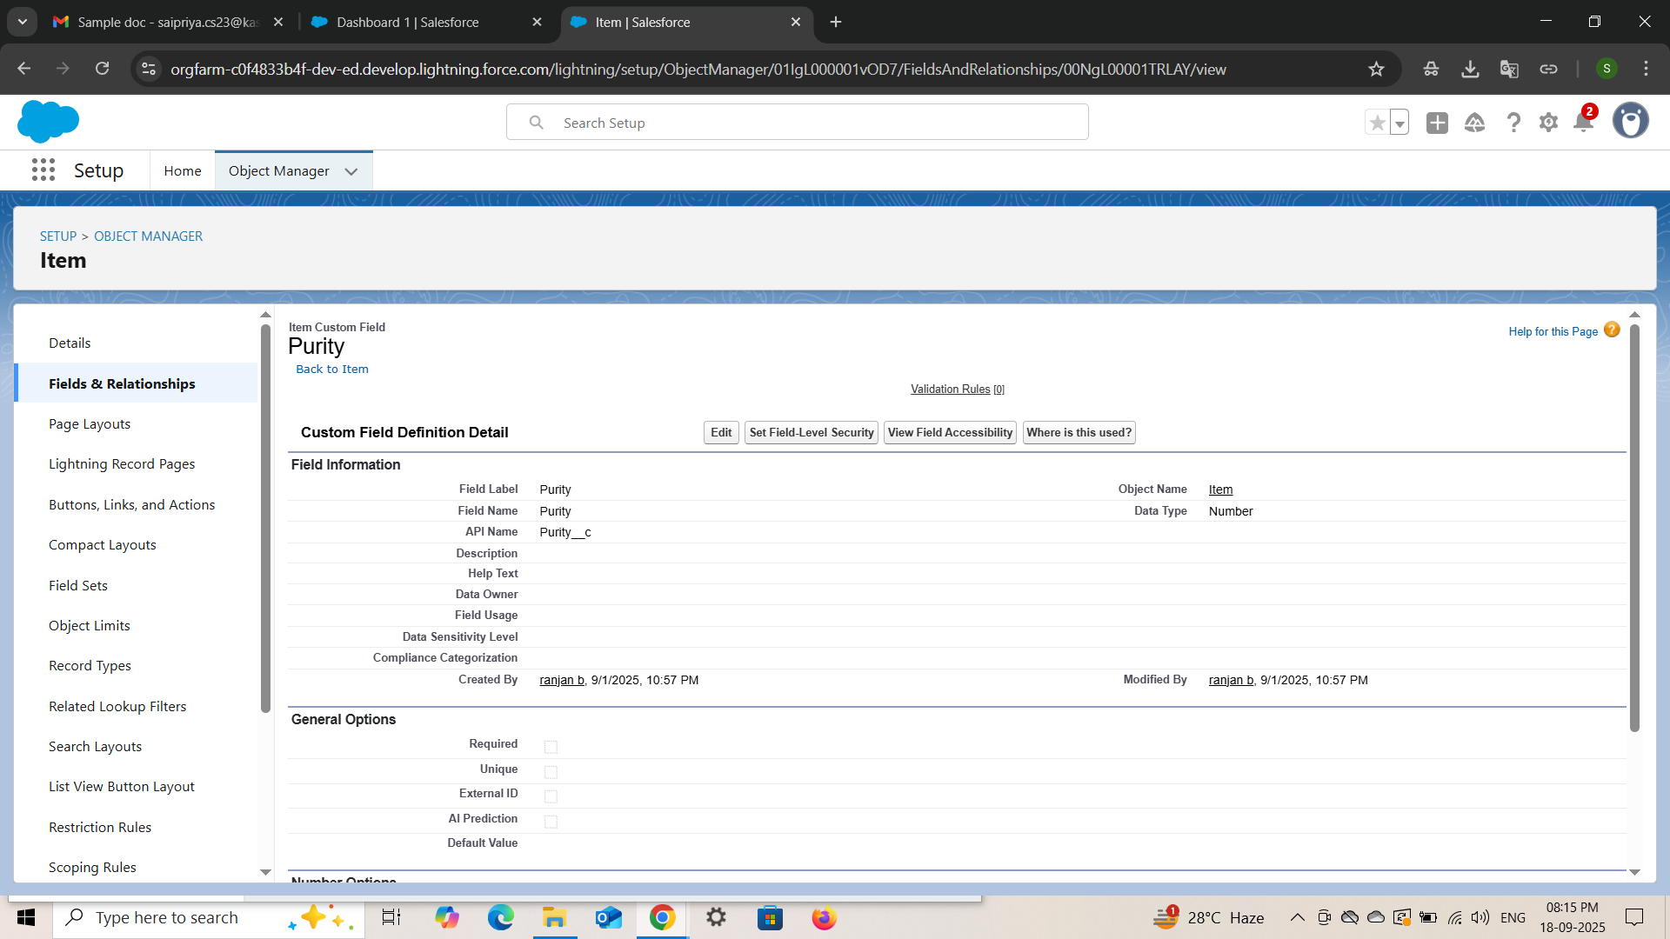

* Creating Picklist Field in Item Object

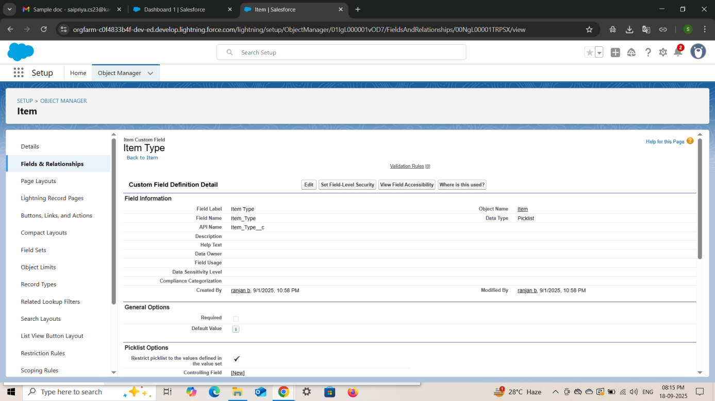

● Creating **Currency Field In Price Object.**

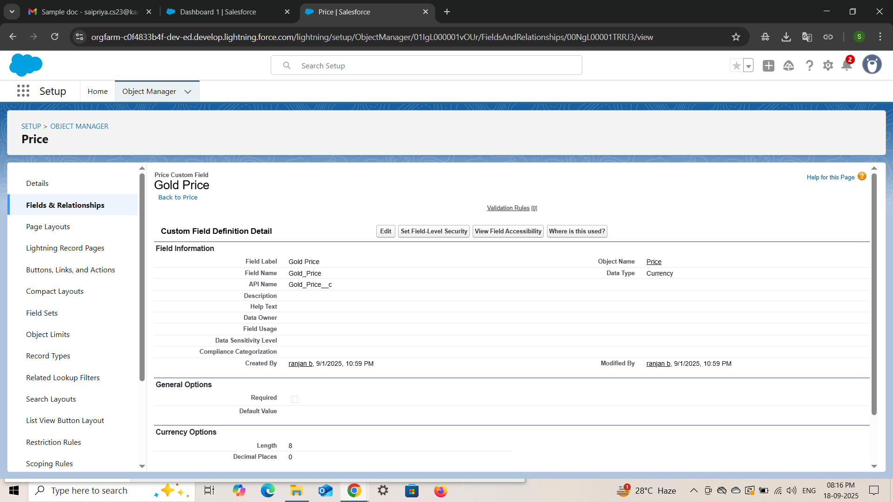

### 

● Creating **Formula Field (Cross Object) in item Object.**

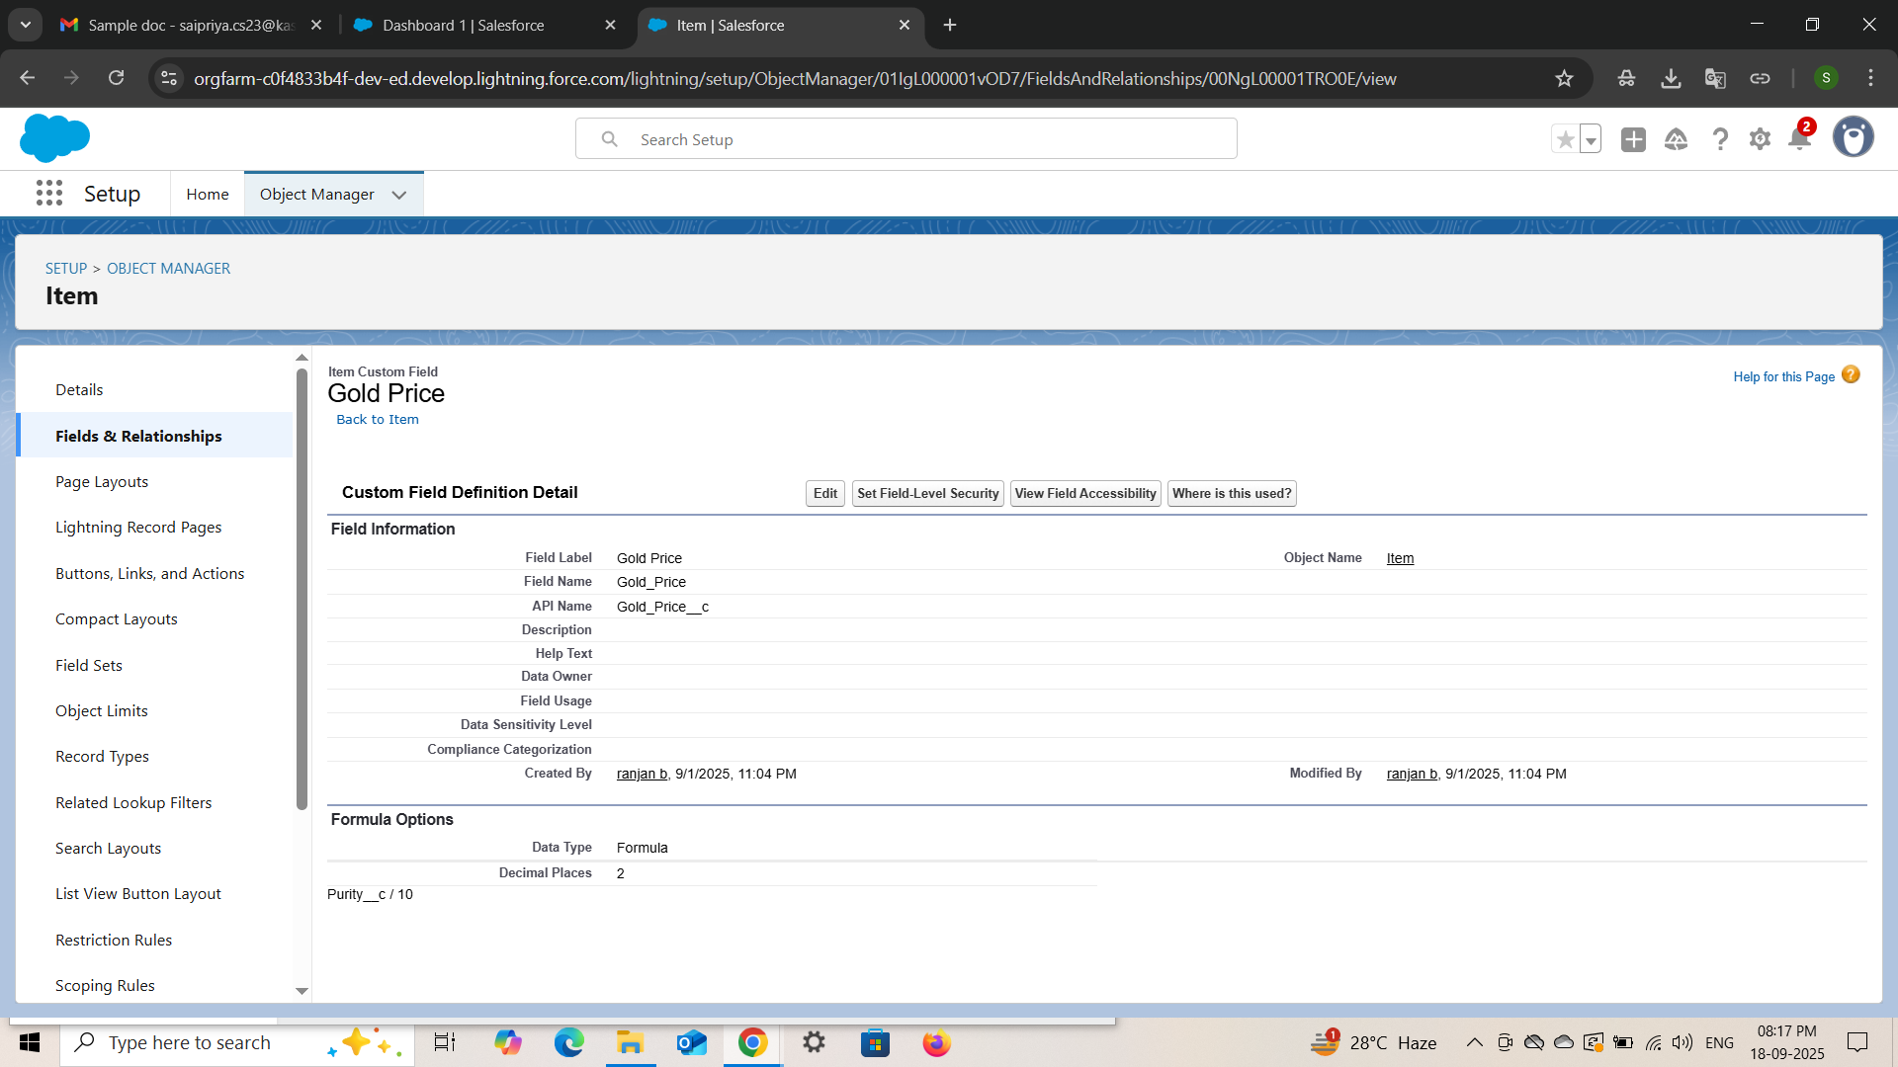

● Creating **field dependencies.**

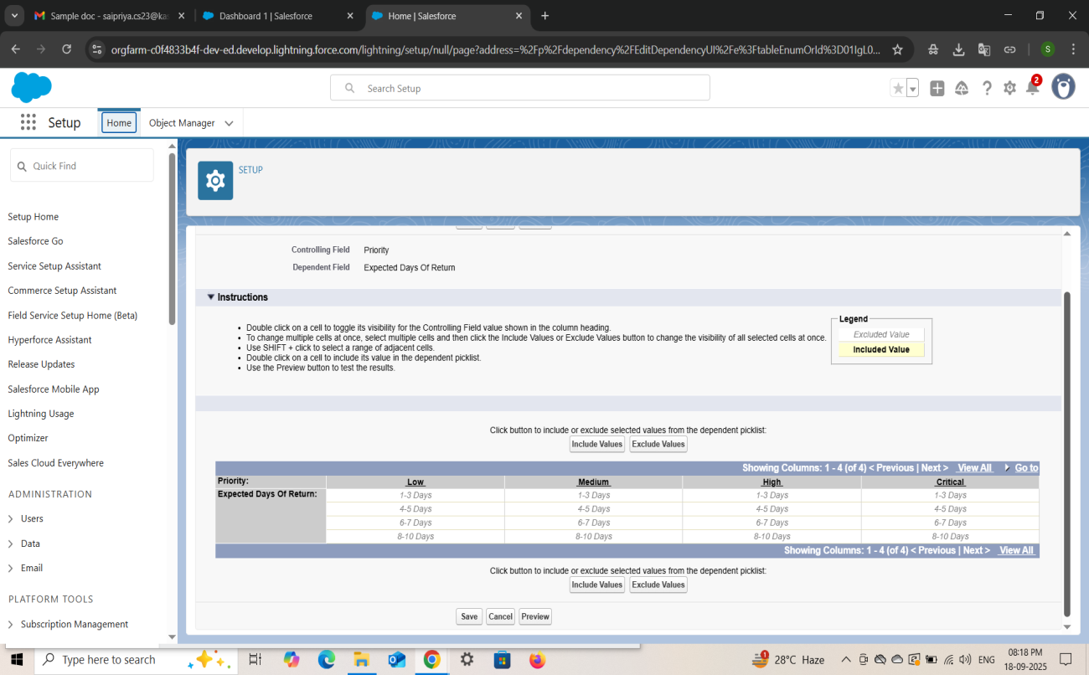

● Creating **the validation rule.**

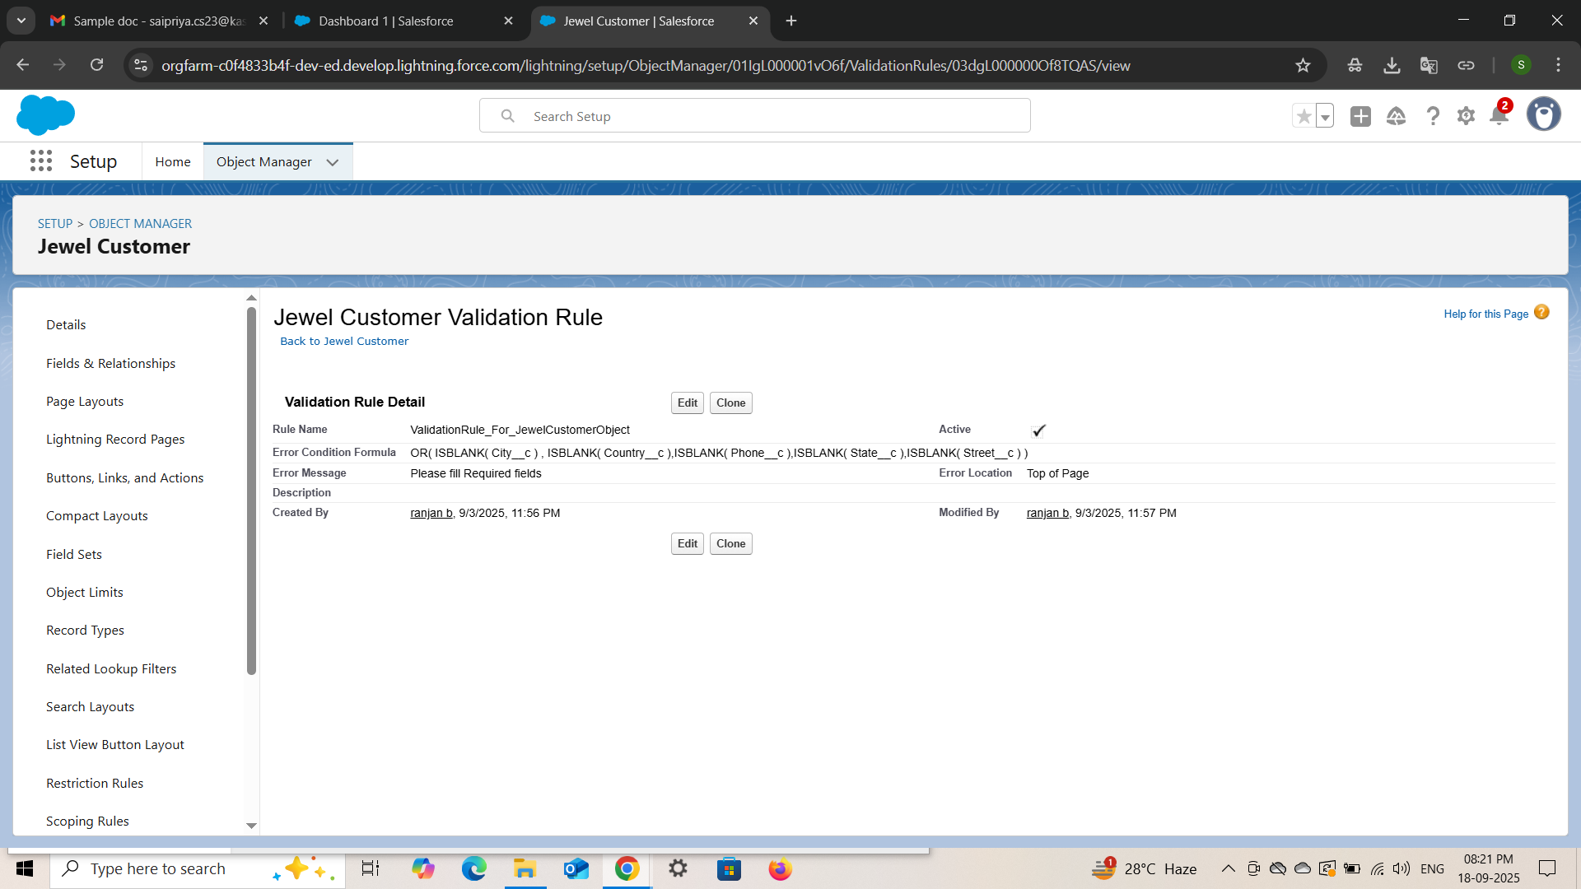

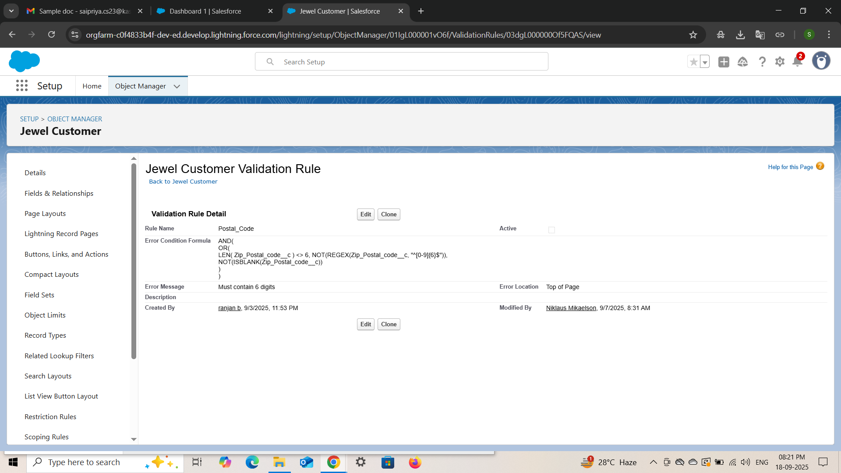

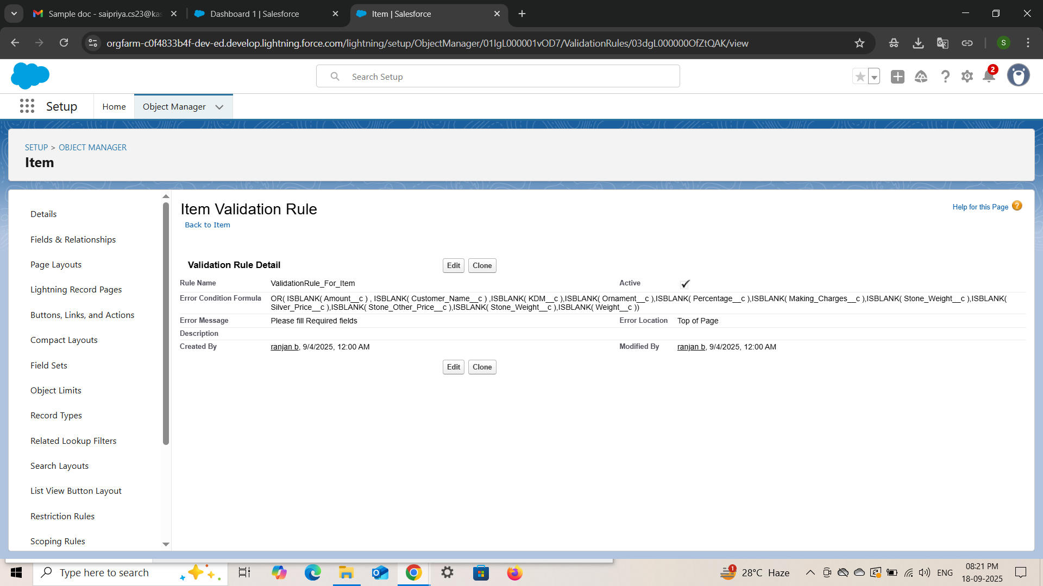

* Creating Profiles :

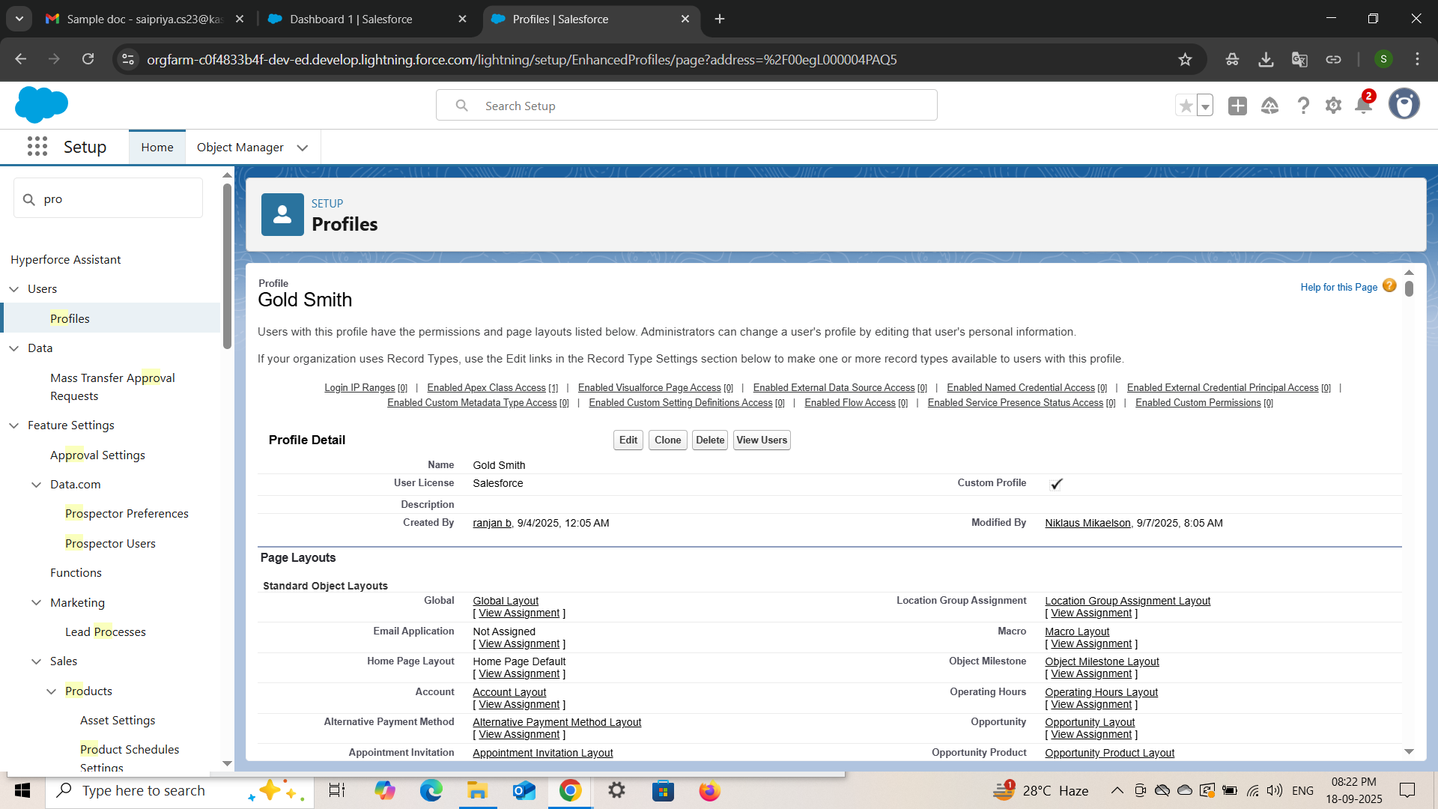

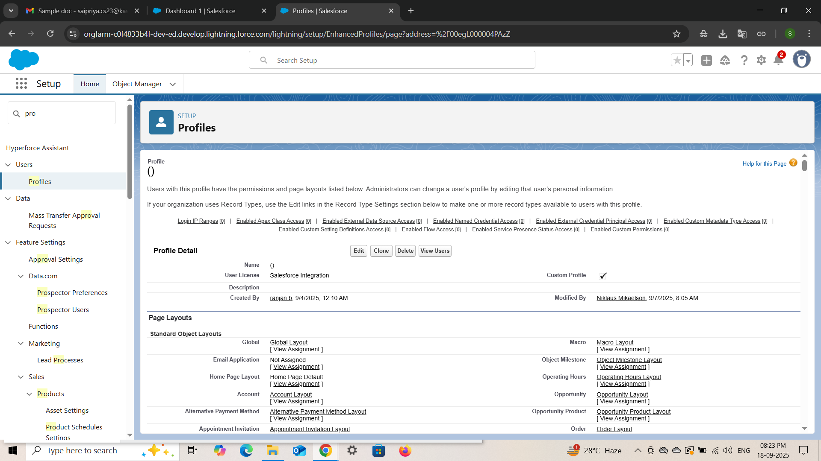

* Creating Roles ( Gold Smith and Worker )

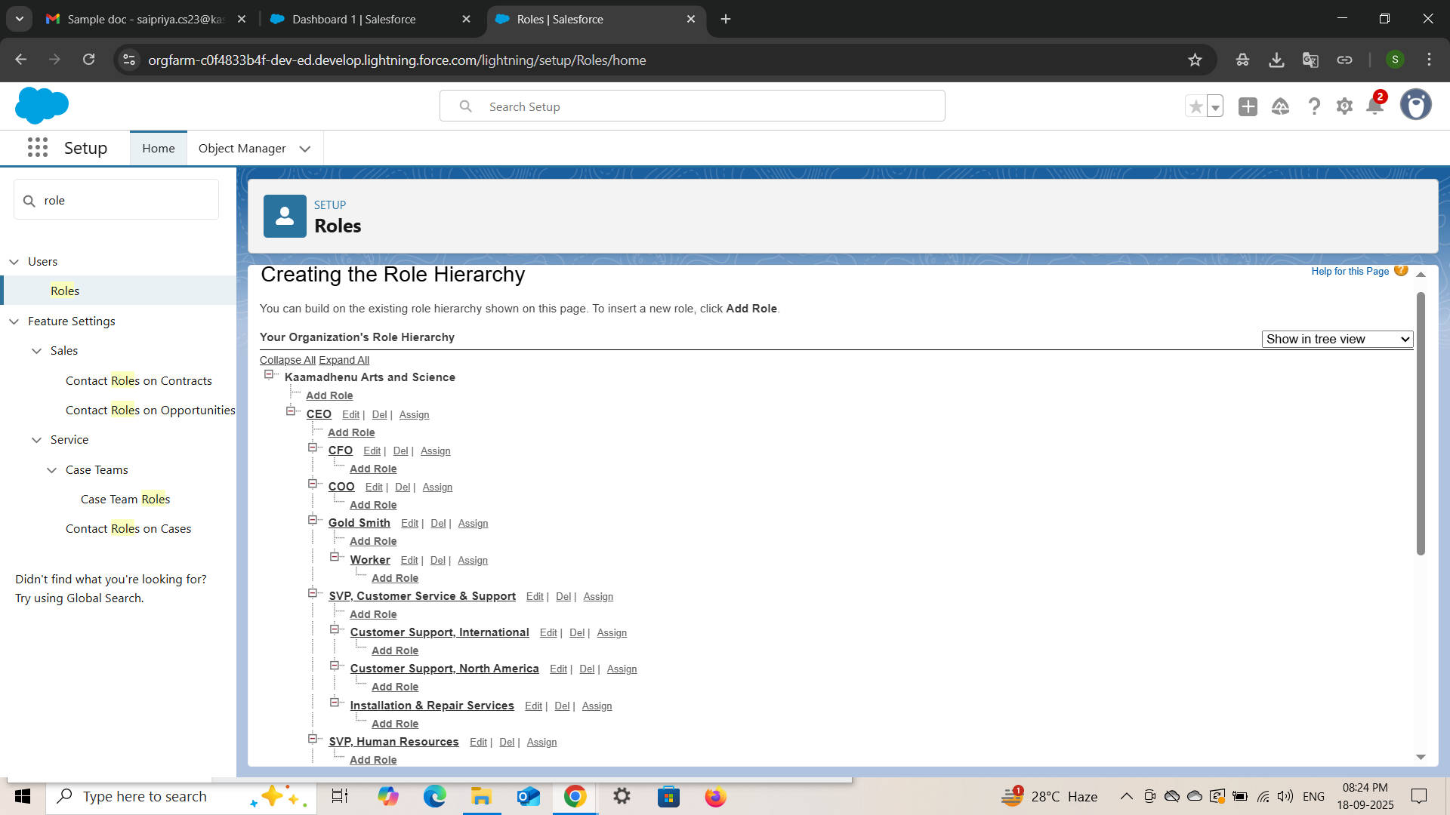

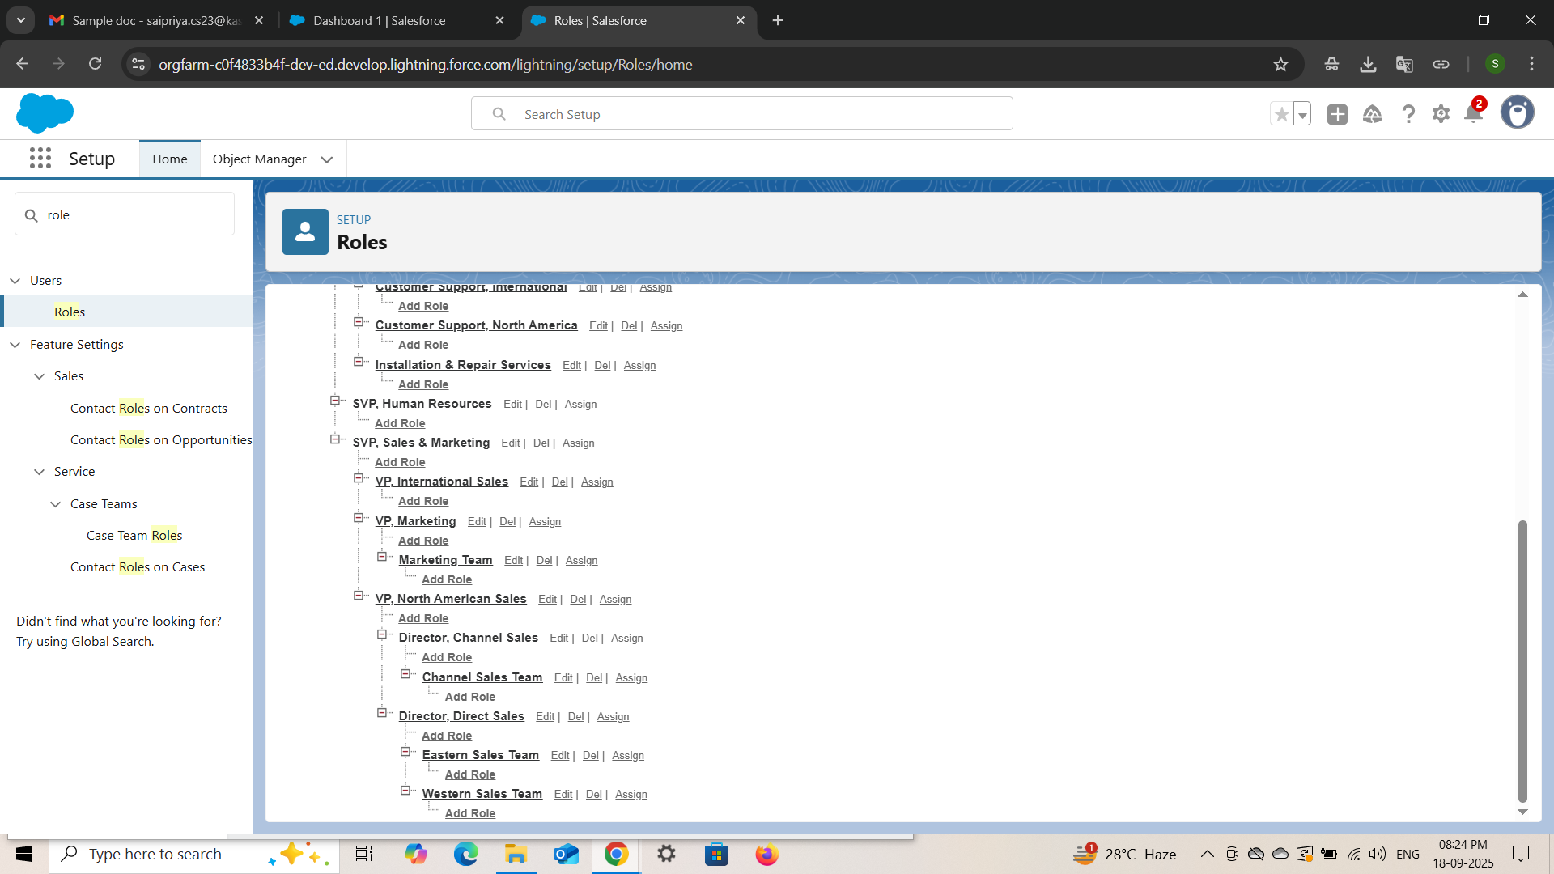

* Creating Users:

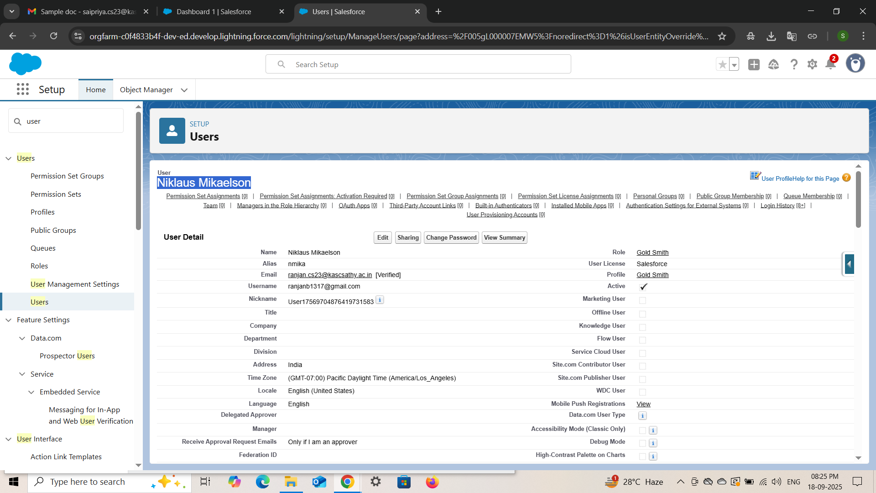

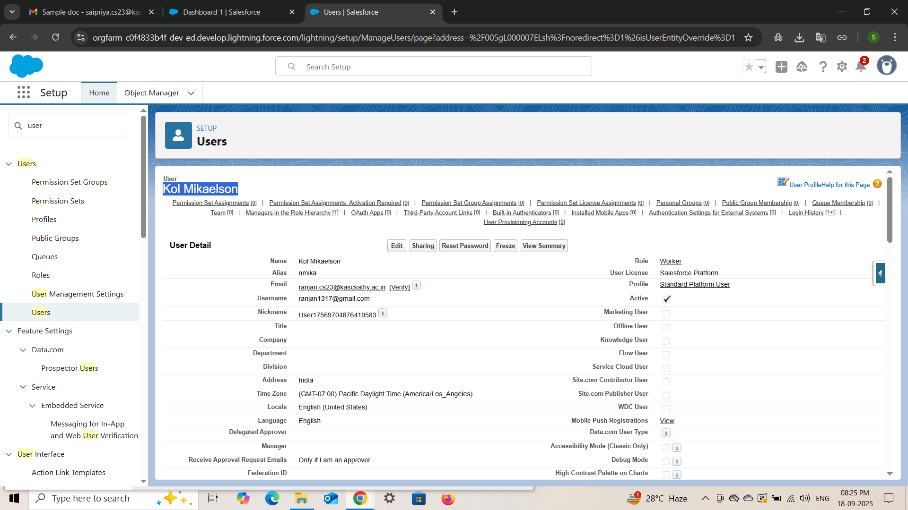 .

* **Create Page Layout : ( Gold, Silver )**

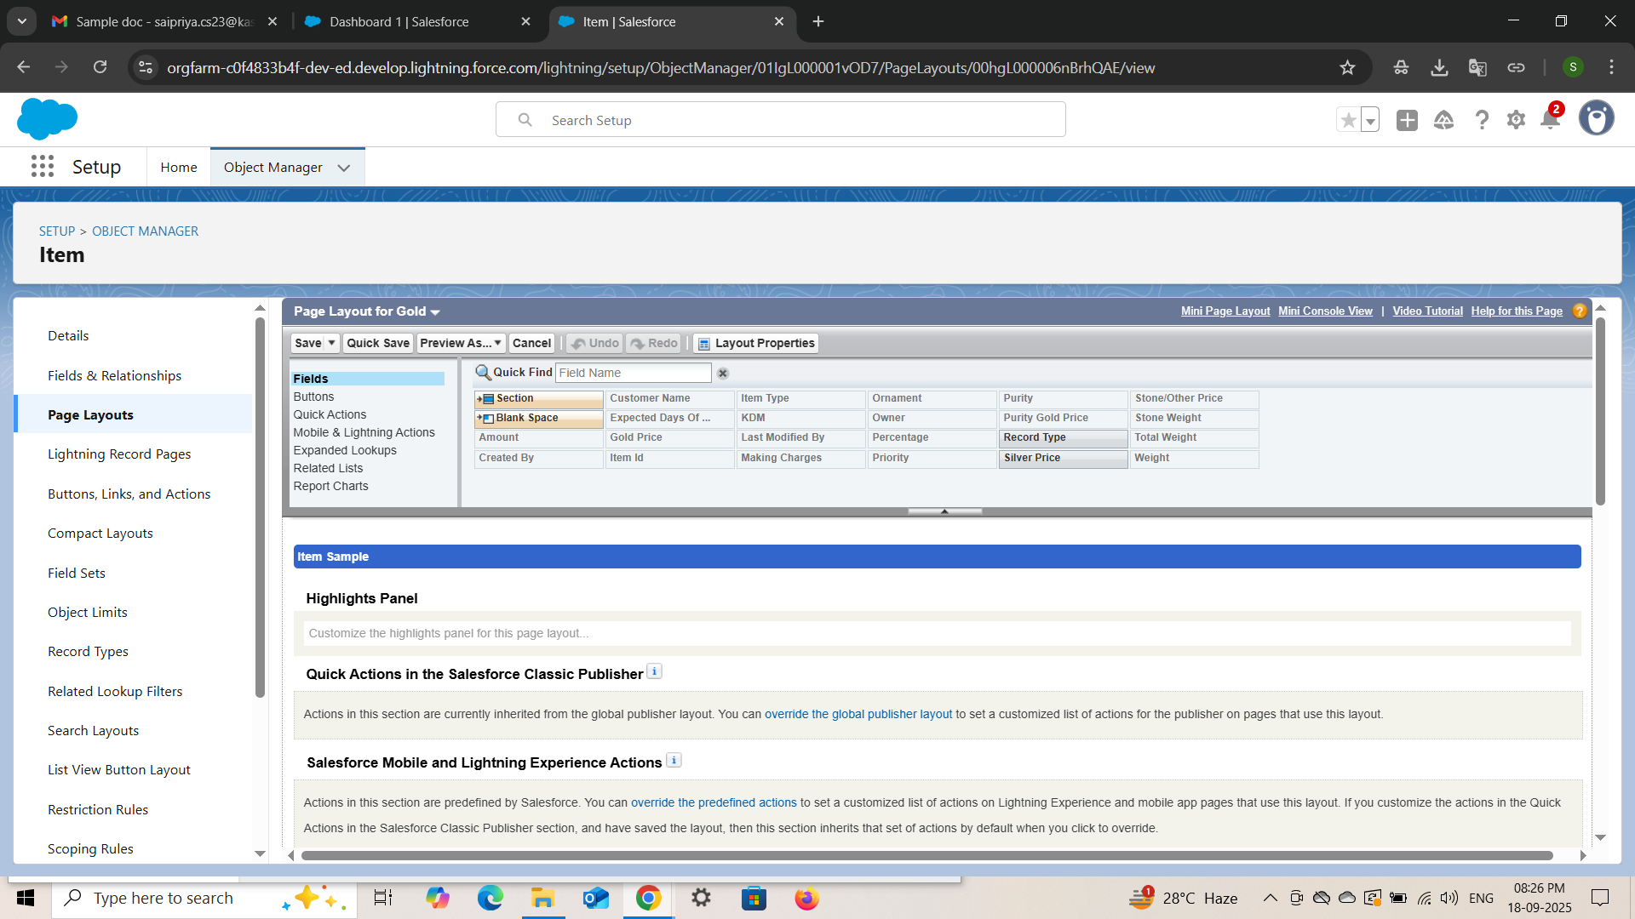

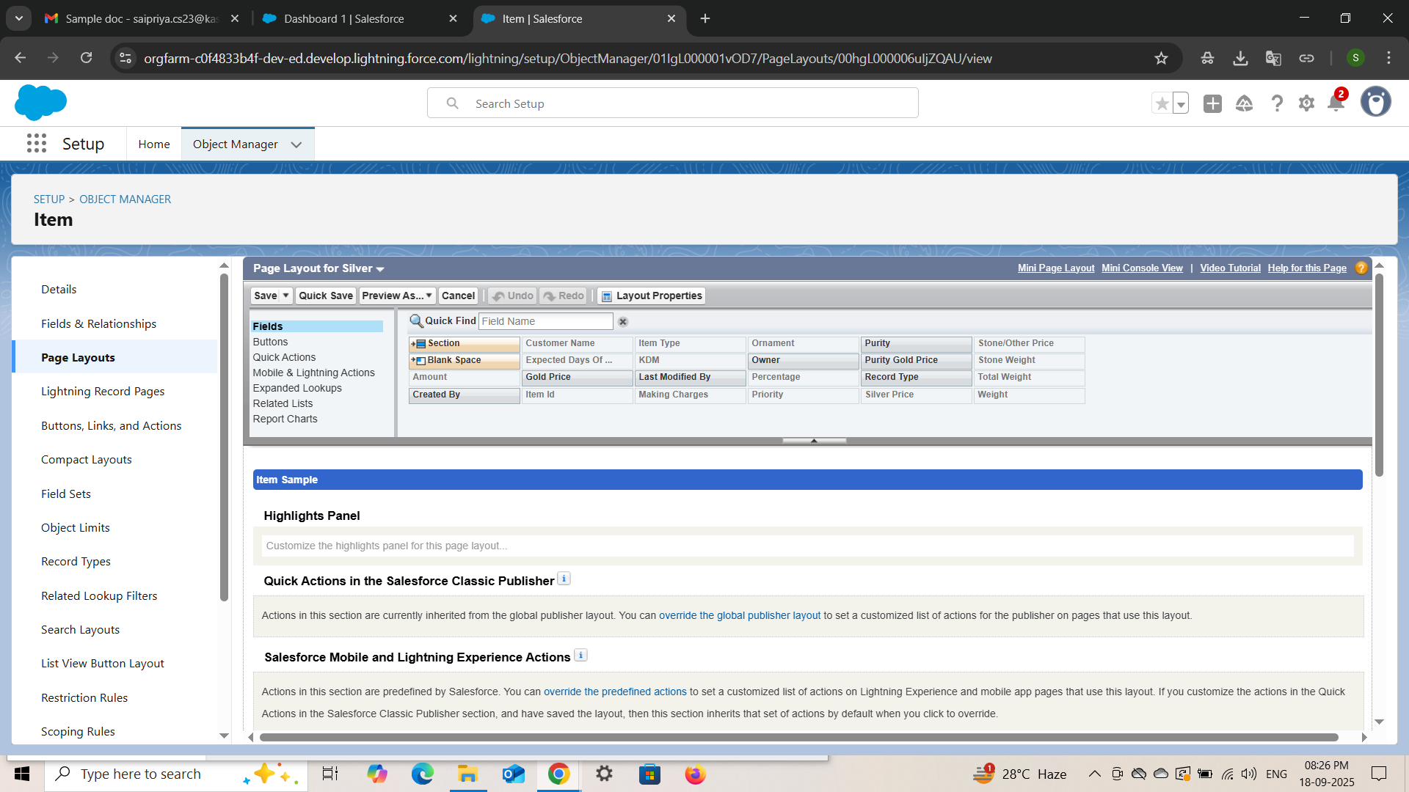

* **Creating a Record Type :**

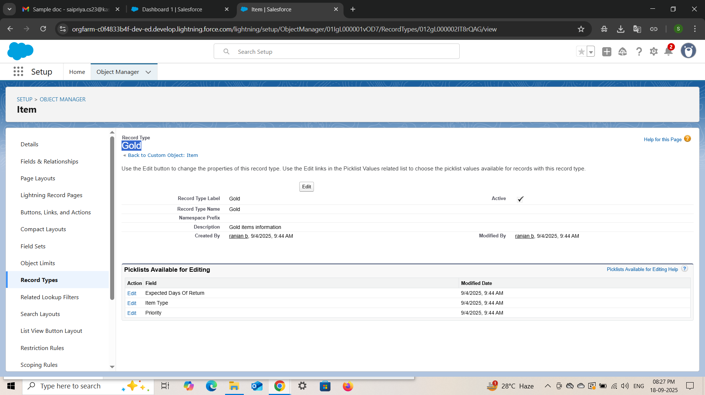

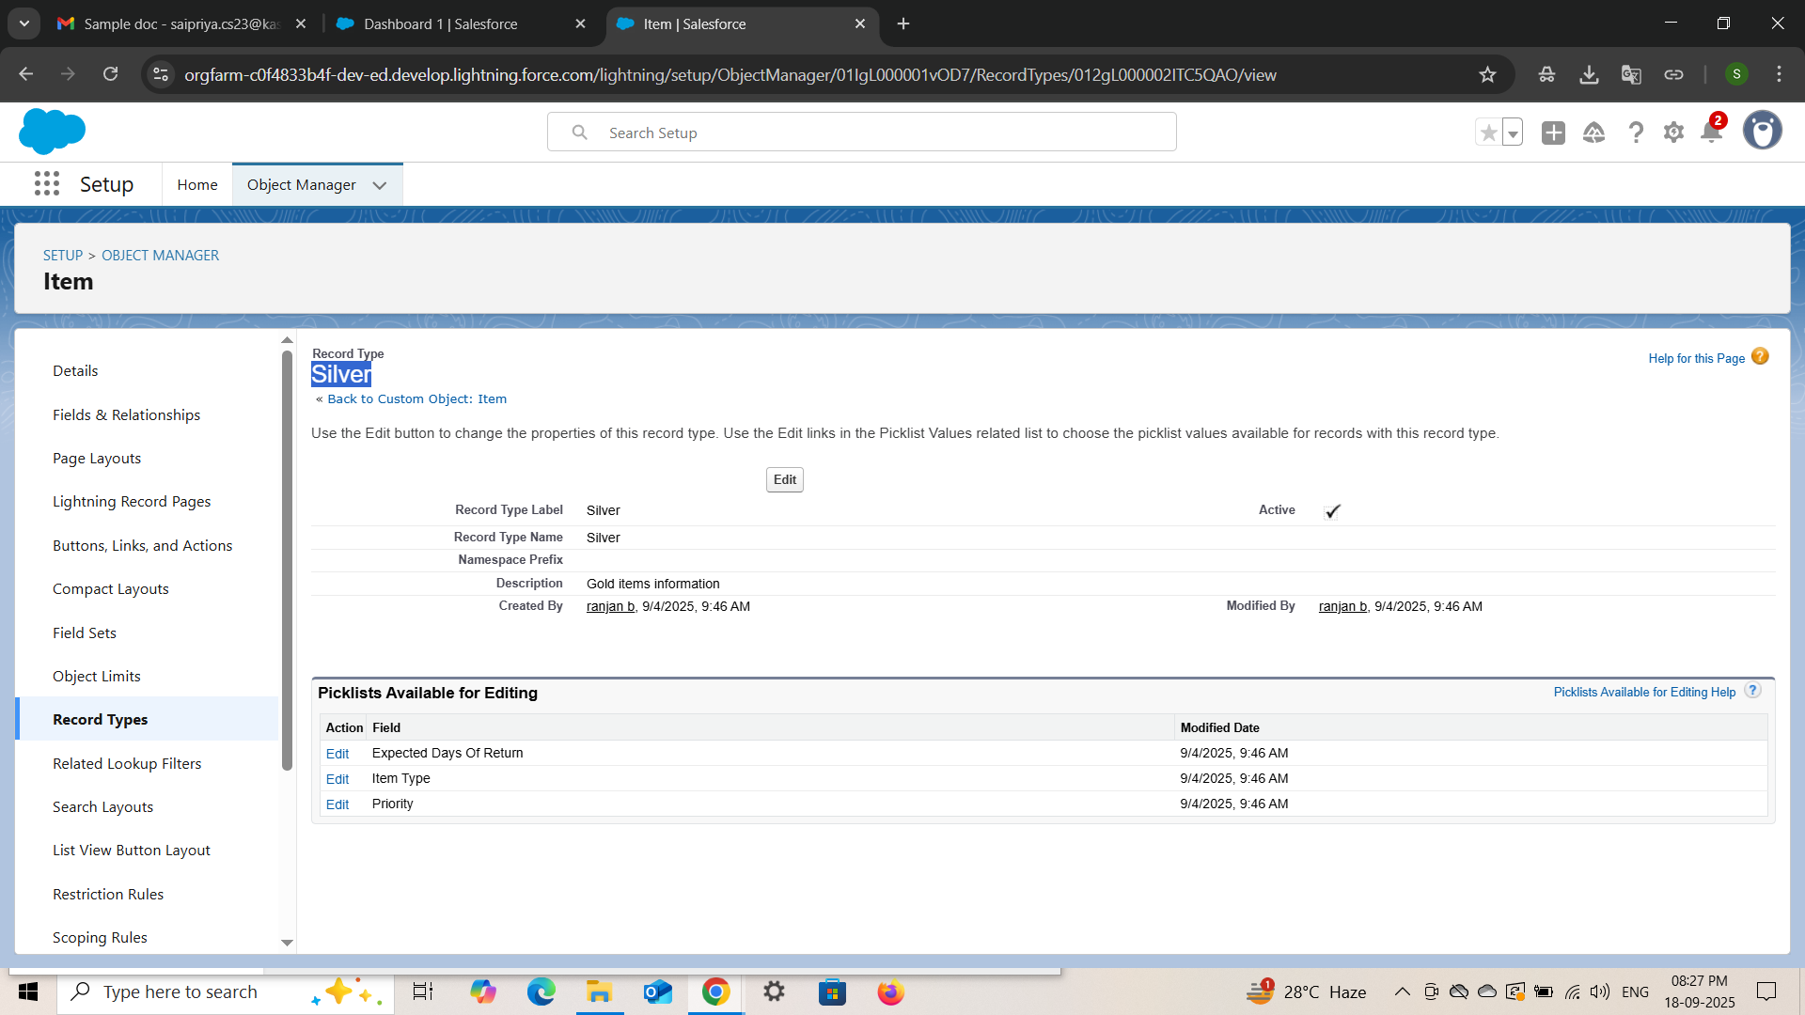

* **Permission Set :**

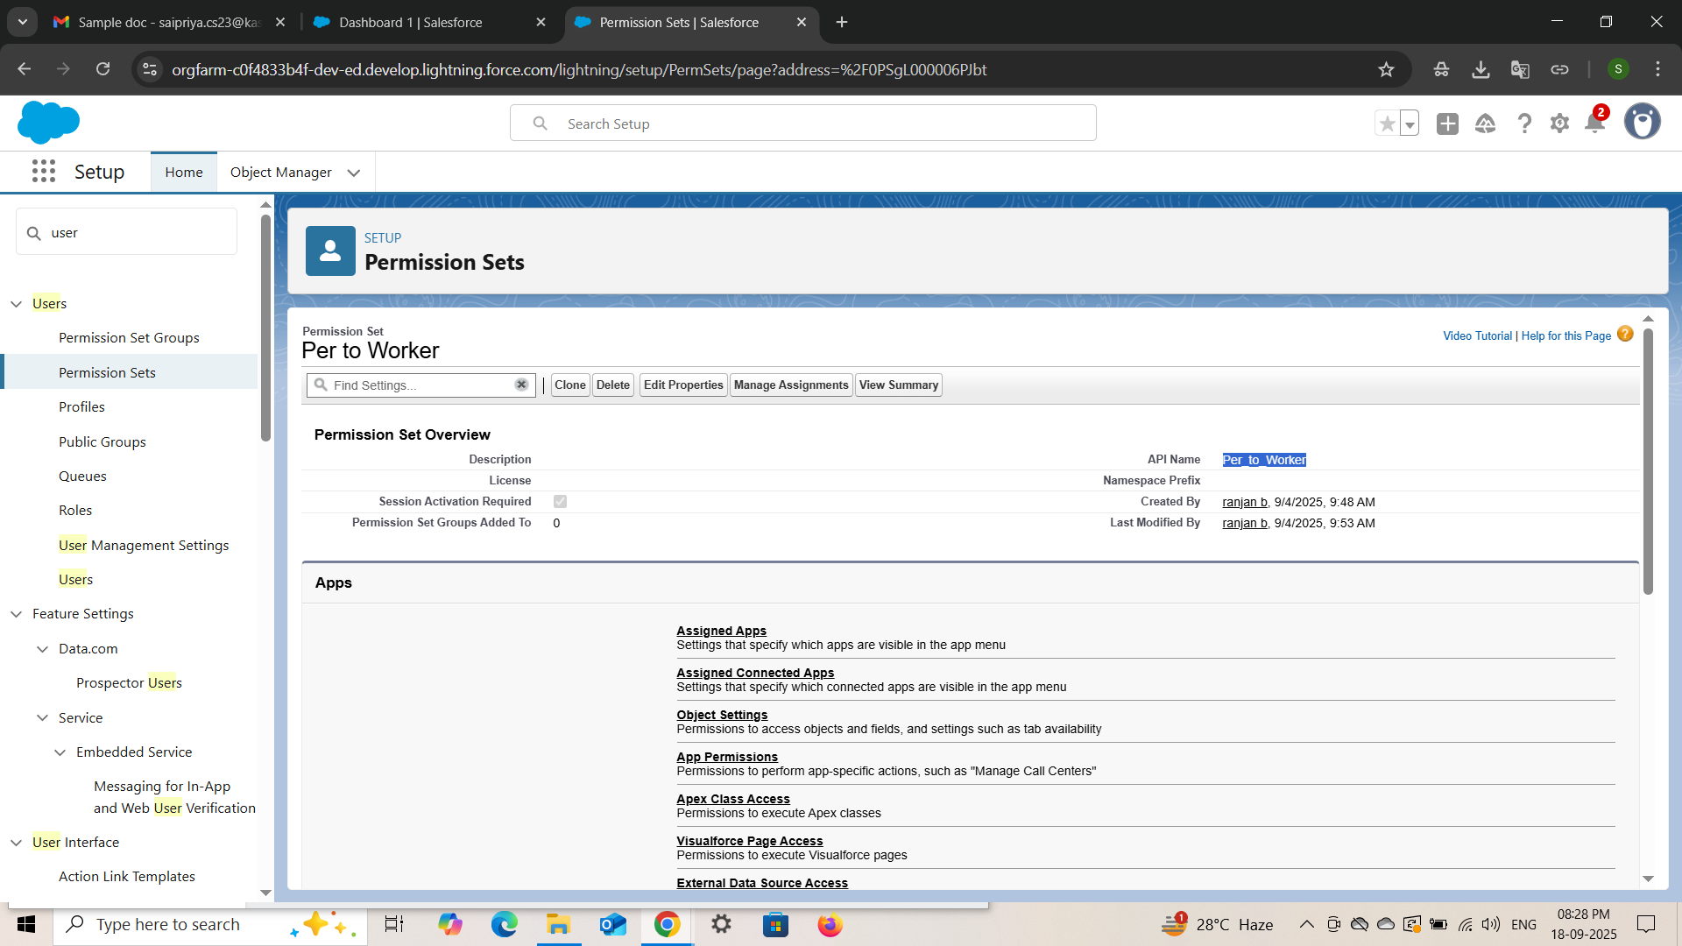

**TRIGGER :**

**Trigger Handler Class :**

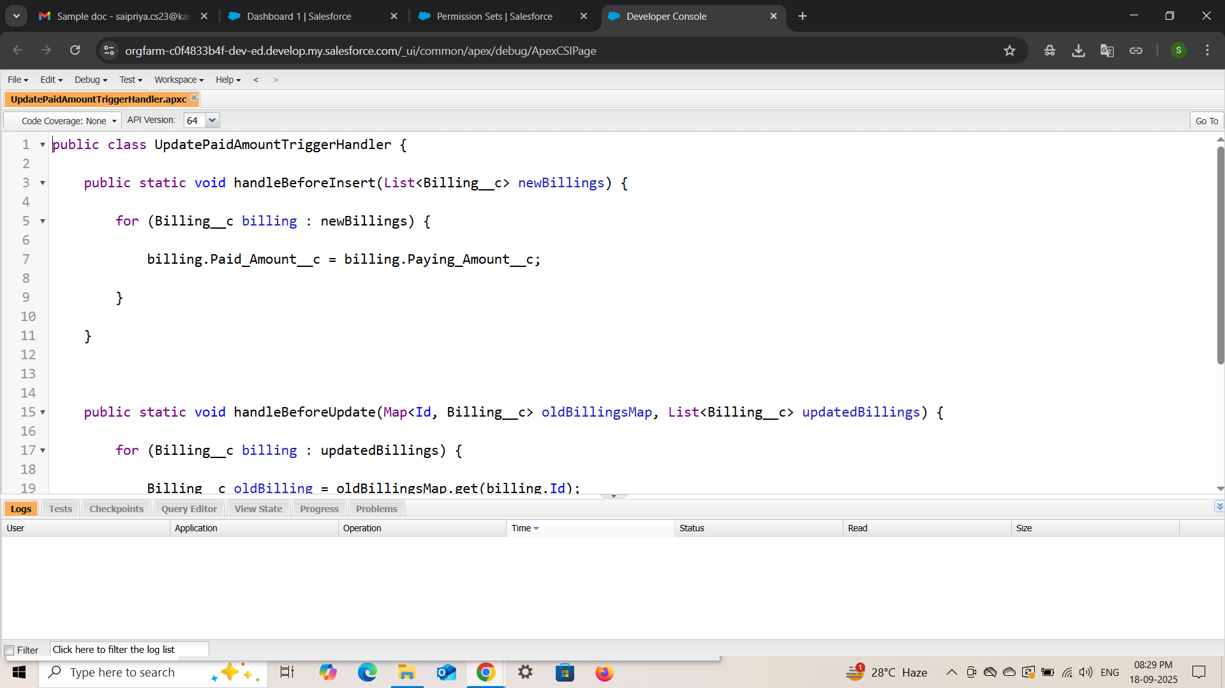

**Trigger :**

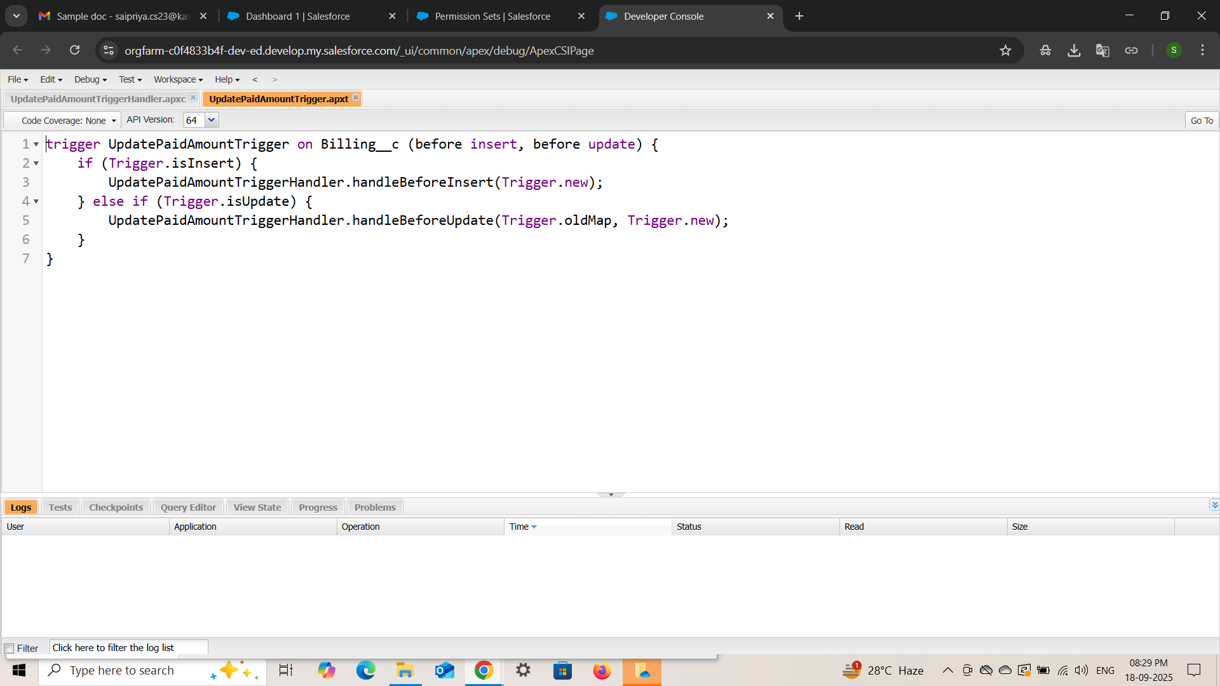

**User Adoptations [ creating a record :**

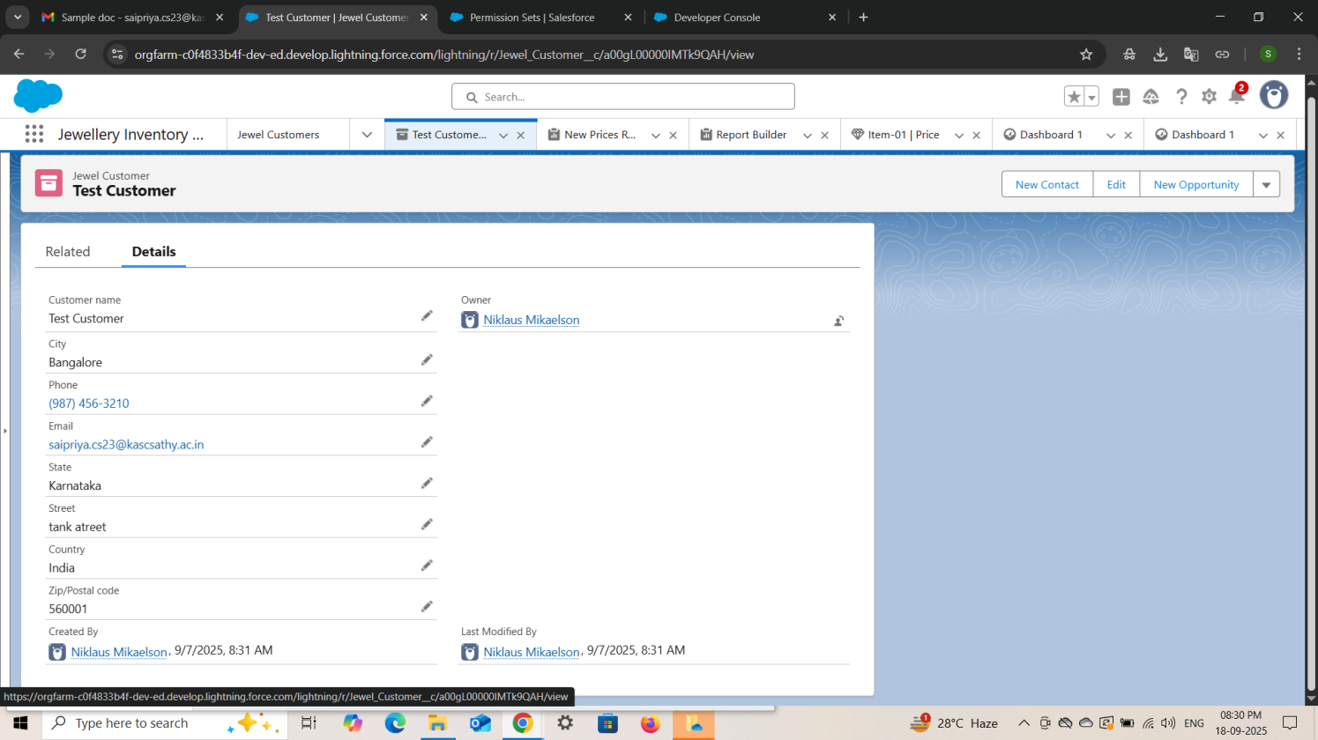

**[ Report ]**

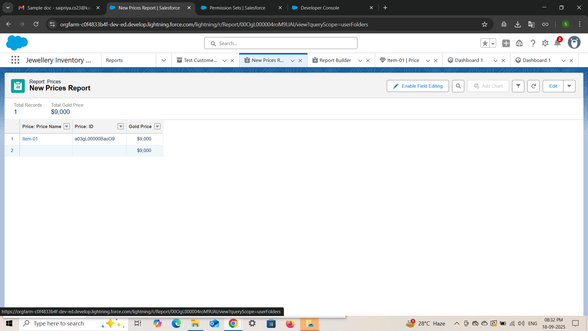

* **Creating of Dashboard :**

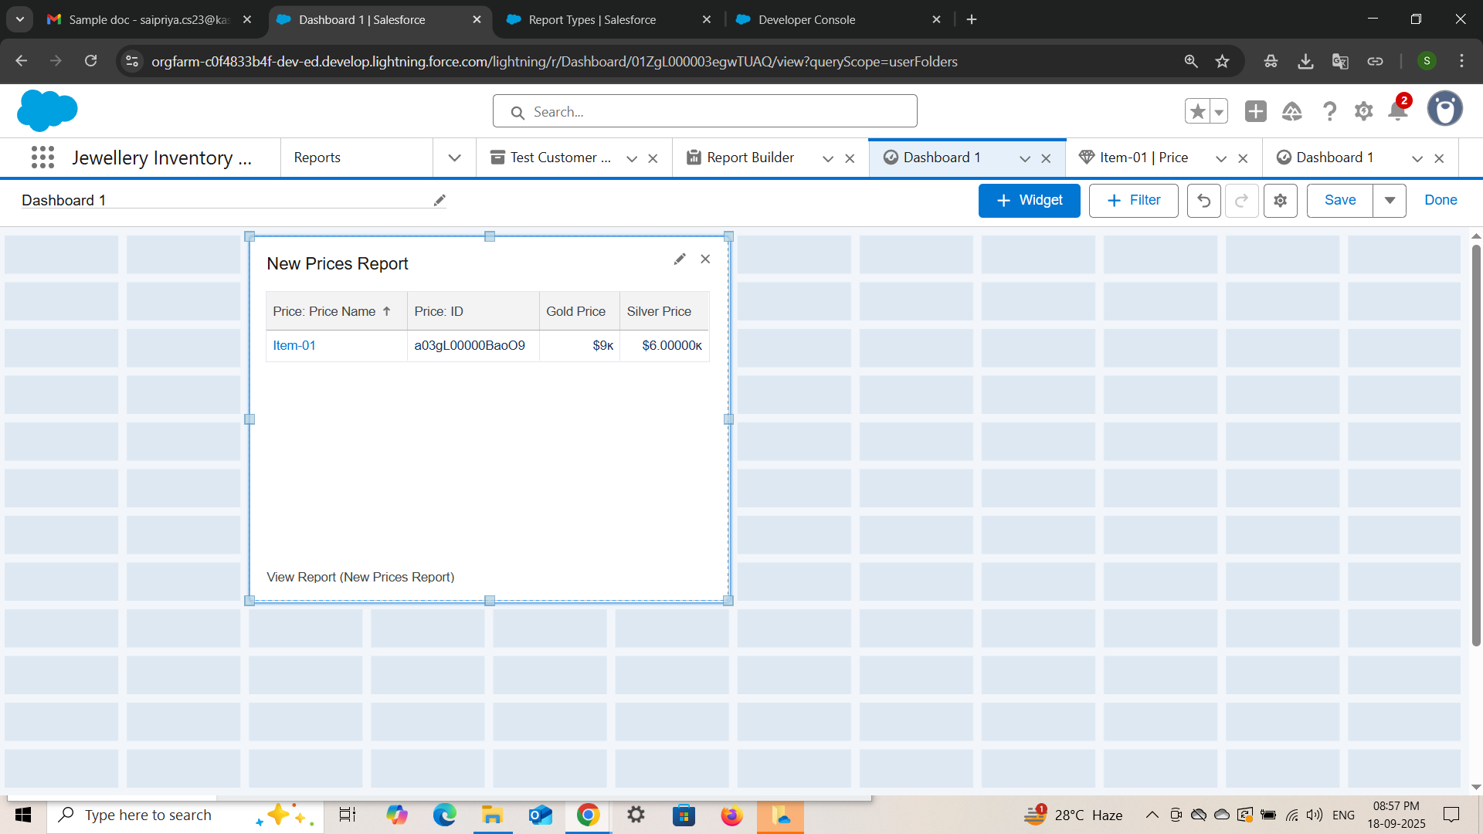

* **Creating a Flow :**

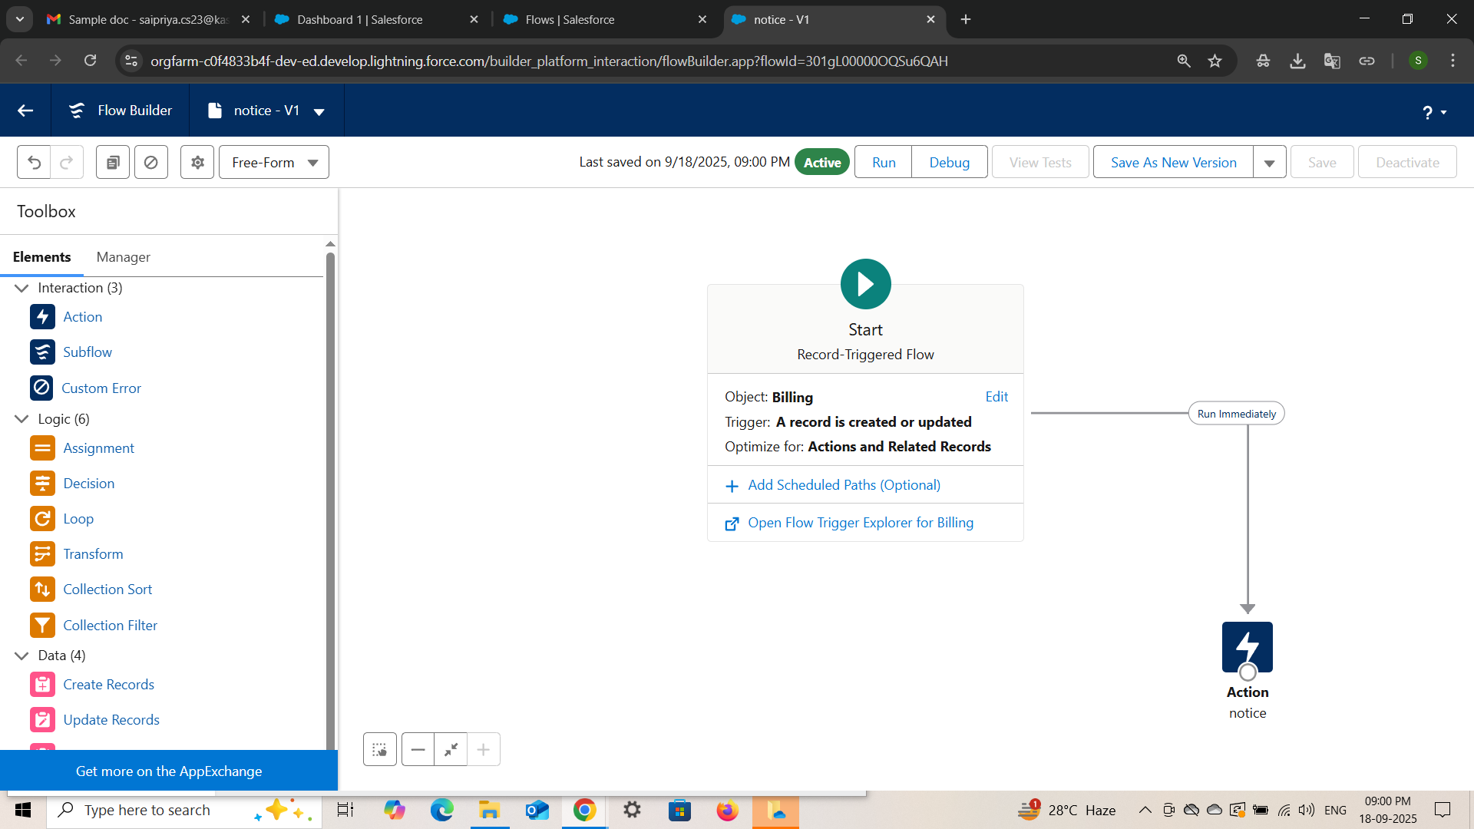

**CONCLUSION**

The Jewel Inventory System serves as a powerful and reliable CRM solution tailored specifically for the jewellery industry. By integrating inventory management, sales tracking, and customer relationship features into a single, user-friendly platform, the system enhances operational efficiency, reduces human error, and improves overall customer satisfaction. This digital transformation not only simplifies day-to-day operations but also empowers jewellery businesses to make informed decisions, scale efficiently, and remain competitive in an evolving market landscape.

.

**APPENDIX**

● **Source Code:** Provided in Apex Classes and Triggers

**UpdatePaidAmountTrigger.apxt** **:**

trigger UpdatePaidAmountTrigger on Billing__c (before insert, before update) {

    if (Trigger.isInsert) {

        UpdatePaidAmountTriggerHandler.handleBeforeInsert(Trigger.new);

    } else if (Trigger.isUpdate) {

        UpdatePaidAmountTriggerHandler.handleBeforeUpdate(Trigger.oldMap, Trigger.new);

    }

}

**UpdatePaidAmountTriggerHandler.apxc:**

public class UpdatePaidAmountTriggerHandler {

    public static void handleBeforeInsert(List<Billing__c> newBillings) {

        for (Billing__c billing : newBillings) {

            billing.Paid_Amount__c = billing.Paying_Amount__c;

        }

    }

    public static void handleBeforeUpdate(Map<Id, Billing__c> oldBillingsMap, List<Billing__c> updatedBillings) {

        for (Billing__c billing : updatedBillings) {

            Billing__c oldBilling = oldBillingsMap.get(billing.Id);

            Decimal oldPaidAmount = oldBilling.Paid_Amount__c;

            billing.Paid_Amount__c = oldPaidAmount + billing.Paying_Amount__c;

        }

    }

}